JERKINS AND JAVA INSTALLATION VERSION :

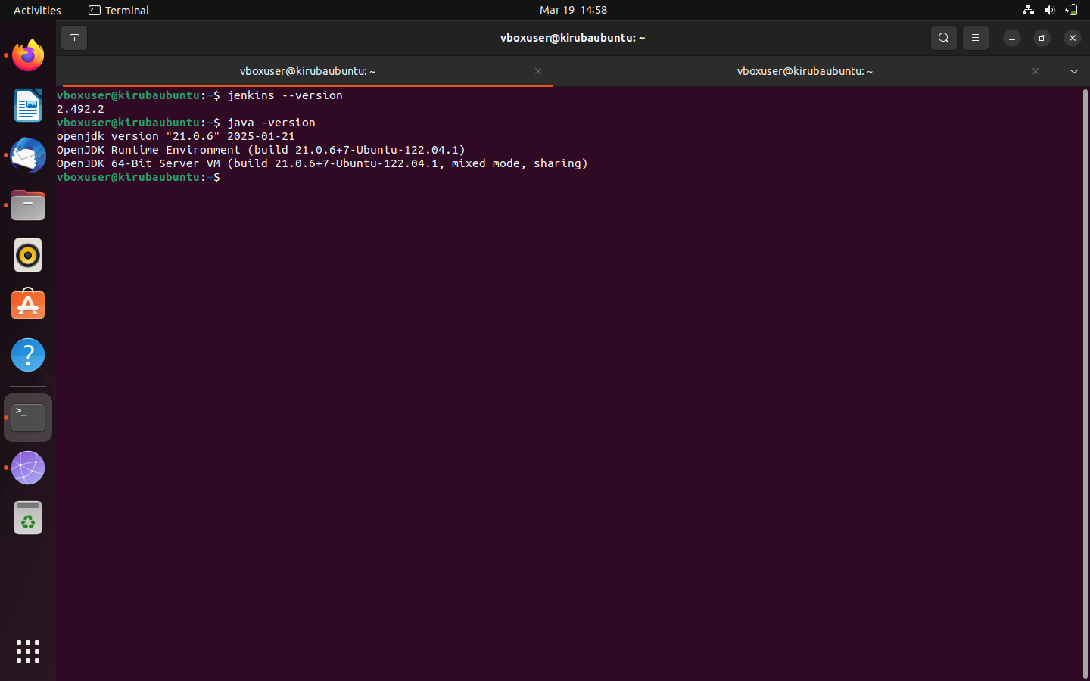

NGINX – LOCALHOST DISPLAY

